Q- 1 What is software? What is software engineering? ans-

**Software** - Software is more than just a program code. A program is an executable code, which serves some computational purpose. Software is considered to be collection of executable programming code, associated libraries and documentations.

**Software engineering** - Software engineering is an engineering branch associated with development of software product using well-defined scientific principles, methods and procedures. The outcome of software engineering is an efficient and reliable software product.

Q 2. Explain types of software?

ans - There Are 5 Types of Software -

1 > Application software

2 > System software 3> Driver software

4> Middleware

5> Programming software

1 > **Application software** -Application software. The most common type of software, application software is a computer software package that performs a specific function for a user, or in some cases, for another application. An application can be self-contained, or it can be a group of programs that run the application for the user. Examples of modern applications include office suites, graphics software, databases and database management programs, web browsers, word processors, software development tools, image editors and communication platforms.

2> **System software** - The OS is the best example of system software.it manages all the other computer programs. software programs are designed to run a computer's application programs and hardware.

Examples- computer language translators and date, clock

3> **Driver software**- Device drivers control the devices and peripherals connected to a computer, enabling them to perform their specific tasks. Every device that is connected to a computer needs at least one device driver to function.

Examples - game controllers, USB storage devices, keyboards, headphones and printers.

4> **Middleware** - that mediates between application and system software or between two different kinds of application software.

Example - middleware enables Microsoft Windows to talk to Excel and Word. It is also used to send a remote work request from an application in a computer that has one kind of OS, to an application in a computer with a different OS. It also enables newer applications to work with legacy ones.

5>**Programming software** - Computer programmers use programming software to write code. Programming software and programming tools enable developers to develop, write, test and debug other software programs. Examples - assemblers, compilers, debuggers and interpreters.

Q 3. What is SDLC? Explain each phase of SDLC ? ans -

**SDLC** -The Software Development Life Cycle (SDLC) refers to a methodology with clearly defined processes for creating high-quality software

* The Software Development Life Cycle (SDLC) refers to a methodology

with clearly defined processes for creating high-quality software. in

detail, the SDLC methodology focuses on the following phases of software development:

1. Requirement Gathering -
2. Analysis
3. Designing
4. Implementation
5. Testing
6. Maintenance

1 > **Requirement gathering** - Requirement gathering is the most important and necessary stage in SDLC. Project organizer set up a meeting with the client to gather all the data like what the customer wants to build,

Before creating a product, a core understanding or knowledge of the product is very necessary.

Example - A client wants to have an application which concerns money transactions.

-In this method, the requirement has to be precise like what kind of operations will be done, how it will be done,

-in which currency it will be done

2> **Analysis** -During this software development lifecycle phase, the specialists meticulously collect precise requirements from the customer to present a solution fine- tuned to their needs. Any unclarities must be elucidated in this stage only.

3> **Designing** - In the design phase, software engineers analyze requirements and identify the best solutions to create the software. For example, they may consider integrating pre- existing modules, make technology choices, and identify development tools. They will look at how to best integrate the new software into any existing IT infrastructure the organization may have.

4>**Implementation** - In the implementation phase, the development team codes the product. They analyze the requirements to identify smaller coding tasks they can do daily to achieve the final result.

5>**Testing** - The development team combines automation and manual testing to check the software for bugs. Quality analysis includes testing the software for errors and checking if

- it meets customer requirements. Because many teams immediately test the code they write, the testing phase often runs parallel to the development phase.

6> **Maintenance** - In the maintenance phase, among other tasks, the team fixes bugs, resolves customer issues, and manages software changes. In addition, the team monitors overall system performance, security, and user experience to identify new ways to improve the existing software.

1. What is DFD? Create a DFD diagram on Flipkart.

Ans- A data flow diagram (DFD) maps out the flow of information for any process or system. It uses defined symbols like rectangles, circles and arrows, plus short text labels, to show data inputs, outputs, storage points and the routes between each destination.

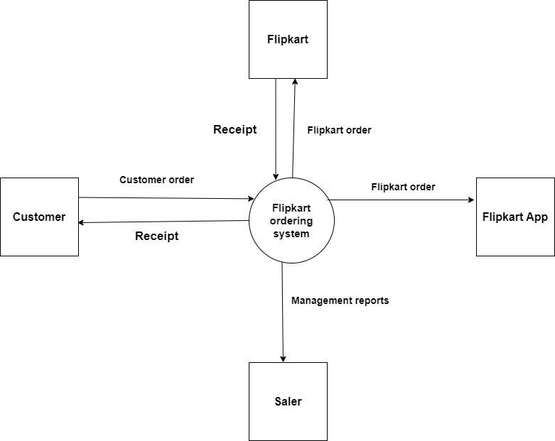

1. What is Flow chart? Create a flowchart to make addition of two numbers

Ans: A flowchart is a diagram depicting a process, a system or a computer algorithm. It is a diagrammatic representation of the solution to a given problem but, more importantly, it provides a breakdown of the essential steps to solving the problem.

**Flowchart:**

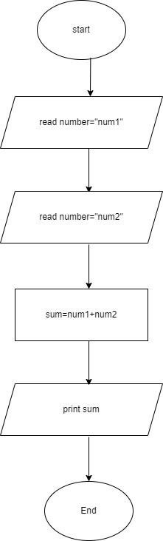

1. What is Use case Diagram? Create a use-case on bill payment on paytm.

Ans- A use case diagram is a graphical depiction of a user's possible interactions with a system. A use case diagram shows various use cases and different types ofusers the system has and will often be accompanied by other types of diagrams as well. The use cases are represented by either circles or ellipses. The actors are often shown as stick figures.

